**ZETECH UNIVERSITY**



Undergraduate in Information Technology

Department of Information Technology

**A Real Estate Management System for real-time financial surveillance and records tracking**

**BY:**

**Patrick Maina Mwaniki Bscit-05-0012/2019**

**Victor Muturi Bscit-05-0016/2019**

**Supervisor:**

Richard Mathenge

**Table of Contents**

A) CHAPTER ONE: 5

ABSTRACT 5

Introduction 6

Background of the Study 6

Problem Statements 6

A Number of objectives are to be achieved by this project: 7

Main Objective 7

Specific Objectives 7

Scope and Limitation of the Study 7

Justification 8

Project Risks and Mitigation 8

B) CHAPTER TWO: 9

LITERATURE REVIEW 9

Introduction 9

Financial Management System 9

Financial Management Systems That Exist 10

Qwetu Hostel Management System 10

Hamis Hostel Management System 10

C) CHAPTER THREE: 11

METHODOLOGY 11

Techniques Implemented for Data Collection 11

Surveys 11

Interviews 12

Observation 12

Implementing and Testing the Project 12

Prototype Modeling Process 12

Process of Making the Prototype 13

Defining System Requirements 13

Design The First Prototype 13

Evaluation of the Prototype 13

Modification of the Prototype 14

Advantages 14

TIME SCHEDULE 15

PROJECT COST 16

# DECLARATION:

I hereby declare that this project is based on my original work except for citations and quotations which have been dully acknowledged. I also declare that it has not been previously and concurrently submitted for any other degree or award at Zetech University

Signature: _________________

Name: _________________

ID No: _________________

Date: _________________

# DEDICATION

I dedicate this project to the Lord Almighty, whose been my source of inspiration, source of my strength through the many adversaries and challenges through out this degree. Special dedication to my beloved mother and father for their constant support, love, and faith in me from the start to the finish line.

# CHAPTER ONE:

## ABSTRACT

For the past few years, creation of business ideas, development of companies and rise of inventions comes as a no brainer as the modern era easily embraces change. Thus as result real estate become one way businesses and entrepreneurs invest their cash as either short term or long term investments. Most of those wanting to enter this niche do by renting out their rental properties expecting the tenant to pay an agreed amount per month. In Kenya property owners have built rental space in the form of flats which increase revenue due to more tenants while utilizing all available land. More tenants directly relates to more problems for example not all people get to pay on time and management of financial books.

### Introduction

For the last few years population growth has led to an increase in rental properties which in turn has lead to a increase in need for residential areas. The project revolves around the management of people who may be in living in such spaces while also making it easier for landlords or real estate agents in carrying out maintenance, release of announcements, receiving payments from residents and keeping of records.

### **Background of the Study**

Real estate can become defined as a combination of land and any permanent structures done on it towards its improve whether man-made or naturally situated. For example, minerals, residential rental property and trees. Residential rental property refers to houses bought by an investor which are occupied by tenants through formal documentation or any other form of agreement. In renting out homes real estate investors have a broad category to choose from to get a high return on investment which include air bnb, student residential areas such as Kwetu hostels, and residential homes.

In looking for a place to stay clients based on their needs conduct research both online, through referrals and agencies, after which they are briefed on the various cost, amenities, etc. A client is required to conduct their own research to ensure they find the best deal which satisfies them. This qualifies to be the norm in most places.

### Problem Statements

How do investors ensure they have proper managements structures that do not prevent clients getting quality services while ensuring finances and resources are well utilized? In Kenya presence of real estate agents. For example Roughson Realtors, are in demand to ensure that rent in paid on time, carry out regular maintenance and resolve issues that may arise on behalf of the property owner. With more than one person involved there may result disagreements especially while requesting tenants to pay monthly rent. This project focuses on methods to ease payment and keeping of records for all parties involved on real-time.

How do real estate agencies manage more than one property while ensuring their company does not run on loses and maintaining transparency among parties involved? Transparency in a company is critical as it determines whether a company is effective and productive. Encouraging transparency among parties discourages skepticism and builds trust in a work environment. An agent may conduct their work with integrity but without records to prove to the owner may deem their words false. A client who could have complained to an owner due to poor services as a result of negligence could experience delays in resolving the issue when transparency is lacking. This project mitigates chances of distrust among parties concerned with residential places.

### A Number of objectives are to be achieved by this project:

#### Main Objective

The main goal of this project is to design a real estate management system linked to a database for financial real-time surveillance and records tracking while also providing a platform tenants and the management can communicate.

#### Specific Objectives

1. Design a database that records data that relate to financial payments by clients.
2. Acquiring a server to provide the means for an agent or manager in management of residential spaces in different locations.
3. Maintain transparency between the agent and clients or property owner via a messenger platform.

#### Scope and Limitation of the Study

This project focuses on management of real estate residential areas on a real-time basis, increasing efficiency and productive by minimizing physical records to digital records that can be easily analyzed and used in making of decisions, and accessed anywhere anytime. The major parties considered are the property owner, client, and an agent. It covered areas such as how payment were to be recorded and retrieved, presence of a form of communication that would become critical in transfer of communication, keeping of financial records and different categorization of bills paid by clients. It however did not cover marketing of residential estates, apartments, and Air BNBS as that could become contrary to the main agenda of the project which focused on the financial perspective of residential real estate management.

### Justification

In a world that quickly embraced technology in the 21st century, Kenya is one of the leading countries in Africa that ranks best at technoprenuership. While this might be the case a research done by the Business Daily indicated that only 35.6% of public companies and 22.9% of private companies in Kenya rely on cloud services (Kariuki, 2017). As more and more companies get to depend on data, more emphasis was needed in backing this technological advancement. This project posed great advantages to property owners and real estates management companies that could benefit from modern technology.

### Project Risks and Mitigation

Risk is an investment perspective can become defined as the probability of an investment not being at per with the expected results. In development of the project certain risks were found and mitigation strategies put in place which include:

|  |  |
| --- | --- |
| Risks | Mitigation |
| Scoop creep which would occur if project objectives were vaguely defined or lack of good communication with my project partner. | My project partner and I divided roles based one’s strengths and weaknesses. Communication was also key via means such as whatsapp calls and texts to ensure information flow was constant and project deadlines were met. |
| Low performance which would become as a result of by poor market research to determine the viability of the project to provide a solution needed in the market place. | Before settling on one project my partner and I discussed a few ideas and their viability, gathering information from friends and experts in the field to discuss what challenges they met and their solutions. |
| High costs which tends to be resulted by a poor budgeted plan, not becoming realistic, and lack of correct information from credible sources. | Consulting with experts in the real estate field were of tremendous assistance in sharing their experiences and costs they incur while running their companies |
| Stretched resources such as inadequate learning materials on programming the system. | In making of the prototype system, sources such as Google, Youtube, Stack Overflow were utilized in debugging of code. |

# CHAPTER TWO:

## LITERATURE REVIEW

## Introduction

This chapter aims at identifying literature works such as textbooks, journals and magazines relevant to real estate, financial management, and real estate management systems previously designed, their advantages and disadvantages while reviewing gaps that need filled by our present project design.

## Financial Management System

Financial management system is a tool that organizations utilize in creating, storing, connecting and reporting of any type of financial proceeding. Its main purpose is counting money flow. Without some level of accounting a business would find it difficult to survive.

## Financial Management Systems That Exist

### Qwetu Hostel Management System

Qwetu hostels is a real estate company that houses students from different universities in Kenya such as Kenyatta University, Jomo Kenyatta University, USIU-Africa and Mount Kenya University ("Most preferred student accommodation in Nairobi - Qwetu.co.ke", n.d.). Their services are in high demand and quality of services is top-notch making it get recognition and nomination. For example USIU-Africa nominated Qwetu Student Residences as its official student accommodation facility. Qwetu residences are located in Nairobi and branches include Jogoo Road, Ruaraka, park lands, Wilson View, Hurlingham, and Aberdare heights. Its management portal includes a dashboard, noticeboard, ticket section, booking, profile and financial details to assist with activities relevant to students and their activities in Qwetu. Key issues with this system include:

* Can it be used on commercial real-estate apartments as opposed to just student residences?
* A noticeboard which informs everyone of major news is a one way form of communication, from the management to the residents.
* At the time of this research its only accessible to Qwetu residents only.
* Information that needs to be transferred in house is done via third-party apps such as Whatsapp.

### Hamis Hostel Management System

HAMIS (Hostel Admistration Management Information System) is a software developed and implemented by Opole Zadock Odhiambo in the University of Nairobi(UoN) for its hostel purposes which include applying for rooms to new and continuing students which can be applied by the parent or student at no cost by visiting [https://smis.uonbi.ac.ke](https://smis.uonbi.ac.ke/) ("Online room application for Academic Year 2021/2022 | University of Nairobi", 2021). University of Nairobi being one of the leading university its hostel host about 10,000 students and partners with external hostel near the city centre of Nairobi town for accomodating interested individuals. Key issues affecting this hostel management system:

* Server not up 24/7 which become inconvenient to those trying to access it.
* Is there presence of an office that deals with issues affecting hostels only?
* The system being integrated with the main student portal has more cons than pros such as those in charge of the hostels are also assigned to other departments, and the complex UI(User Interface) makes it difficult for first time users in operating the system.
* Presence of a notice board within the hostel management system lacks in the system for easy transfer of major hostel related updates.
* How do students raise their complains that relate to the hostel?
* With the rise in technology the hostel management system lacks an established IT department that ensures the system is up to date with latest technology trends.

# CHAPTER THREE:

## METHODOLOGY

This chapter entails methods that were used to obtain the objectives of the real estate management system. Also, techniques implemented to gather data and facts, conduct data analysis, implement and test the project (Prototype modelling process) , and measure cost of the project and schedule time were included in this chapter.

### Techniques Implemented for Data Collection

Data collection for the project was categorized into surveys, Interviews, and observation.

#### Surveys

In determining how tenants look for houses, pay rent, communicate with the management and challenges faced by the management in ensuring quality services are rendered to their clients forms will be issued to both tenants and the property managers each with a set of open-ended and closed ended questions to have good grasp of parties involved.

#### Interviews

Students living in Qwetu and University of Nairobi will be interviewed to rate their hostel management system provided and whether they are satisfied and if not, what are some of the things they would recommend incorporated.

#### Observation

Observation will be carried out to see if a new easily navigate the system of both Qwetu and UoN and their expressions used in making of our financial management system.

## Implementing and Testing the Project

### Prototype Modeling Process

Prototype modeling is a process in whch a prototype is built, tested and modified until the best system is achieved onto which the finalized system can be developed. The model allows quick but inclomple design of the system ensuring risk is minimized while maing it possible to show technical feasibility. User requirements become better understood while ensuring risks and cost is reduced before more resources are committed into forming the final project which is illustrated below:

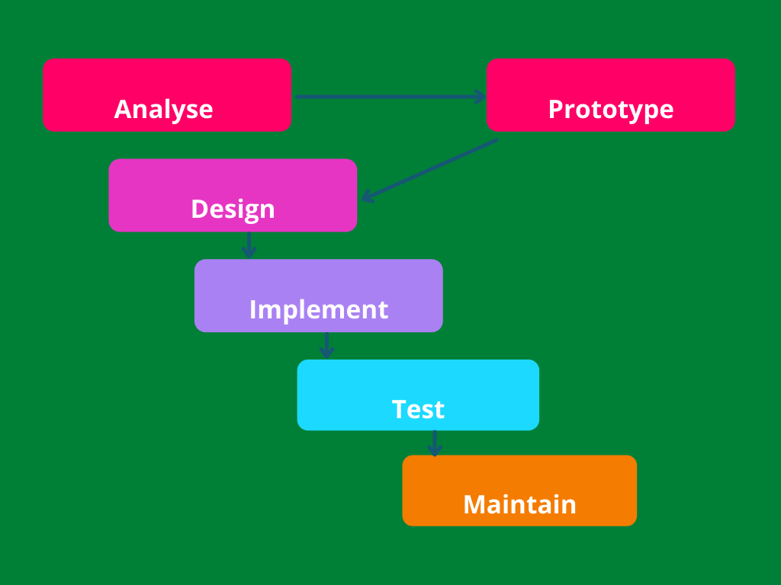

## Process of Making the Prototype

### Defining System Requirements

Basic requirements of the prototype are determined which involve the input and output data needed. Complex requirements such as security of the design can be ignored.

### Design The First Prototype

A simple design of the system is made to give a brief idea of the complete design to the user.

### Evaluation of the Prototype

The end-user or client gets to review the prototype giving their feedback on strengths and weaknesses of the model.

### Modification of the Prototype

Refining the prototype is done using the feedback received until its fully working and the user is satisfied

### Advantages

* Customers are in a position to view the product early in the production stages ensuring customer satisfaction.
* Requirements that may be raised can be included early.
* Functionalities that may be missing can be easily inserted.
* Errors that could arise can be noticed much earlier.
* After development of the prototype the developer may reuse it in the future for complex projects
* Designing of a prototype is flexible.

## TIME SCHEDULE

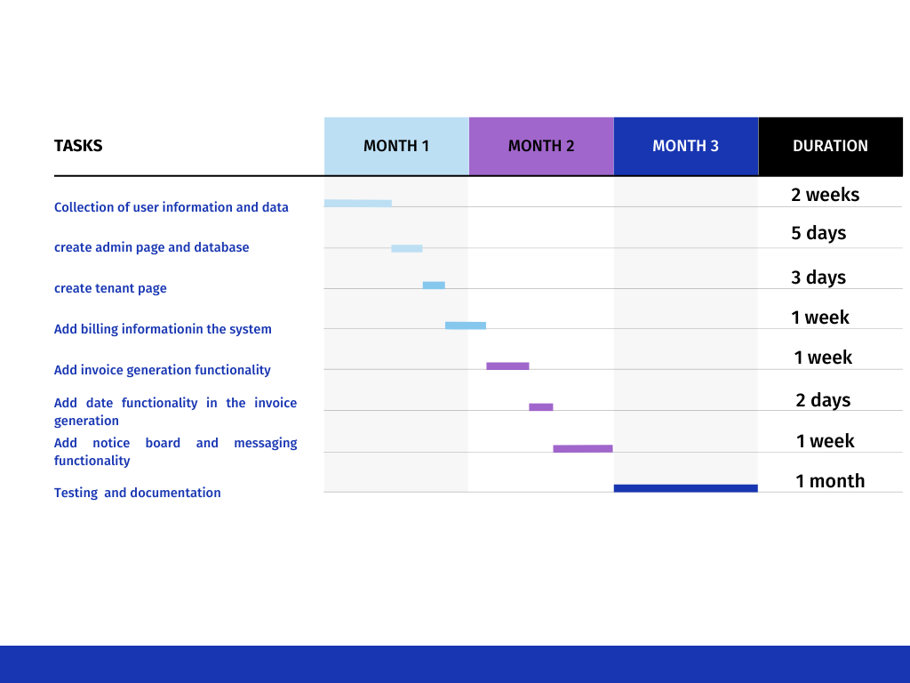The gantt chart represents the different functions to be implemented in the financial management system and duration it takes for each to be completed.

## PROJECT COST

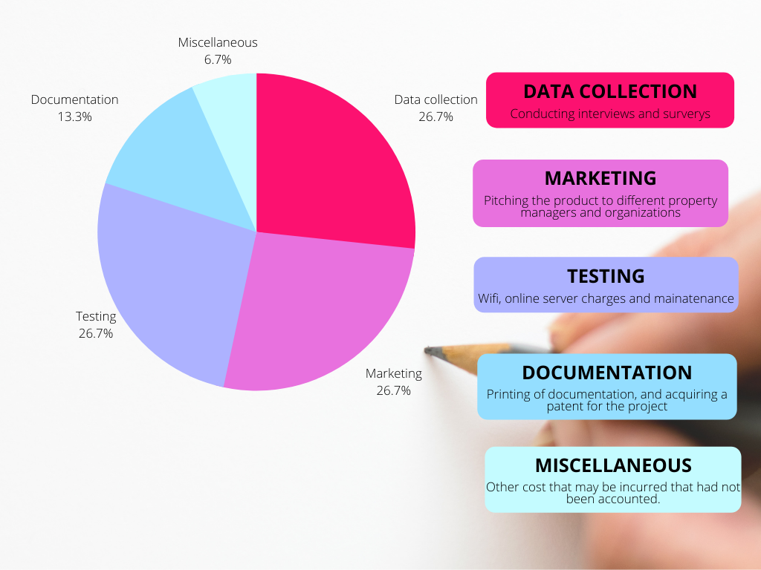The pie chart above represents Ksh 50,000 divided into various cost for implementing the project.

# CHAPTER FOUR:

## System Analysis

A system is a computer program that is made to run application programs as well as machine hardware. Systems become developed to solve problems. System analysis can be defined as idenifying a la rger software and dividing it to various sections with the aim of knowing how each part functions so as to achieve a particular goal. In this case the real estate financial management system has various sections that include Admin page, Tenant page, Invoice generation, Notice board, Login page, Payment page and update Payment Page.

## Tools used in analysis:

### Observation

The method involved use of direct observation of results and financial reports. Processes such as collection of rent, managing of receipts, giving out of notices and tenants raising issues were noted and methods in which these processes got handled by the property manager(landlord/ landlady) or a real estate agent. Observations were carried out on Willbet flats Ruiru in Kiambu.

**Objectives**

How new tenants are received.

How financial records were kept and retrieved.

How collection of monthly payments is done.

How tenants directed their complaints to the management

**Findings**

The willbet management handled their financial records both manually and utilized technoligical equipment which included computers and mobile phones. After a tenants pays their rent the secrectary offers a receipt to confirm they’ve paid that month’s rent and details such as house number, amounts paid and date is included on the receipt. Payment for trash was not included which was used in payment of third parties to transport the trash. We also noted that incase a tenant has a complaint such as electrical connection that occurred on a weekend, they had to wait till Monday for their issue to be discussed and sometimes had to raise the issue again since the person in charge had forgotten.

### Interviews

Conducting of face to face interviews was carried out on the tenants and the management personnel using a set of predefined questions.

#### Objectives

To understand if the tenants felt secure in the apartments.

To know is they preferred use of electronic means of payment or use of cash.

To know the various policies withing the compound.

To know when tenants were expected to have cleared their monthly payment

#### Findings

It was clear that delays were present in payment of rent and at times during the holidays for example December, number of tenants with rent arrears would increase.

Keeping up with the many records per year which had become recorded in a receipt book was tedious.

Communication between the tenants and the management was minimal.

## Limitations of Willbet Financial Record System

Insecurity of financial data stored on physical files had made it difficult in ensuring security of receipts.

Data loss which occurred as a result of manual files that had previously stored getting damaged and misplaced hence if the tenant of property manager required them it was unavailable.

Delay in operations as retrieving of records was slow and some records could not become retrieved due to file loss.

Data integrity was an issue as some records could be duplicated as a result of there being too many forms of managing payments.

Analysis of financial records was time consuming as records of more than an year were kept and such data in its raw form required more resources to convert it to useful information.

## Formation of new system requirements

Conversion of all manual receipts to computer generated receipts.

Provision of a communication platform that acts as a place to refer.

Privacy centered system that ensures only authorized persons can access the database.

### The requirements aimed at addressing problems acknowledged:

* Lower the cost of managing financial books.
* Reduction to cost of labor
* Improve business processes.
* Improve on security relating to financial records.
* Minimize resources required to convert financial data to useful information.

**Our real estate management system**

As earlier stated in chapter 1 this project was built to overcome challenges that property managers and real estate agents face when managing more than one tenants as well as tenants become integrated into the system so as to receive notifications from the management and can also raise any concerns that could arise in their stay to allow a conducive environment for parties involved.

#### Functional requirements

A functional requirement is explained as a description of particular service a software was created to offer to the market. A function refers to the inputs into a software system, how it is processed and its outputs.

In the financial management system the Admin gets all Administrative priviledge such as he or she creates new tenants by the help of a user interface provided in the Admin Dashboard. The Admin adds tenant payments, updates their payment, and distributes public notifications.

Once the tenants has become registered into the database, their email and password becomes their login credentials thus getting authenticated. A tenant has the options chatting directly with the Admin, generating an invoice and he or she can view if monthly balances are present and receive both public and private notifications.

#### Non-functional requirements

They are functions such as security, performance, scalability ,reliability, usability, implementation and software

**Usability**

* Included functions that could affect the systems usability
* Response time
* Well, simple to use user interface to both the tenants and the Admin.

**Implementation**

The management system was applied in a web environment. The operating system used is windows 10 which acts as the platform and xampp server acted as the web server.

**Software**

MYSQL is structured as a relational database management system built on the Structured Query Language. Its function is to access and manage records formed in the table

**Interface**

**The system was was built using CSS, HTML, PHP, MYSQL**

**Hardware and Software requirements**

|  |  |
| --- | --- |
| Requirements | Recommended properties |
| OS (operating system) | Windows 7 and above |
| Processor | Core two dual and above |
| Browser | Google Chrome, Firefox |
| Database | MY SQL |

**DATA FLOW DIAGRAM OF THE PROPOSED SYSTEM**

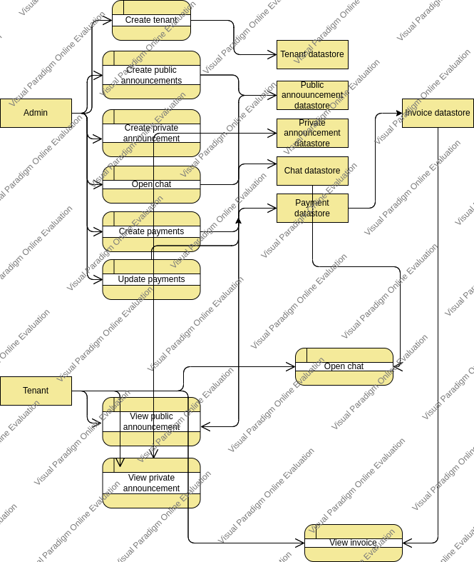

**Admin**

Functions of Admin as shown

Add new Tenant include (view tenant)

Add public notification include (view public notification)

Add private notification include (view private notification)

Add payment include (view payment)

Add updated payment include (view updated payment)

Add message include (view message)

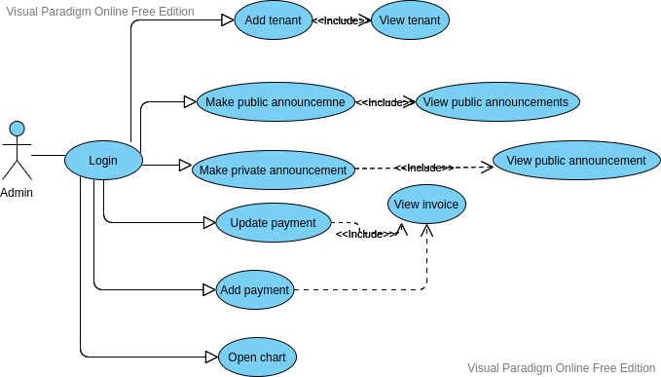

**Tenant**

Functions of admin as shown

View public notifications

View their private notifications

View their invoice

Add message include (view message)

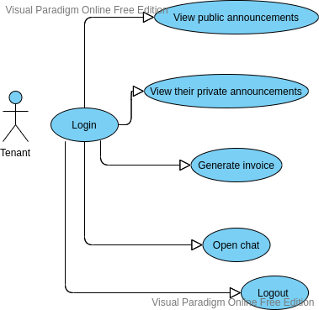

# CHAPTER FIVE:

## SYSTEM DESIGN

In this chapter explanation gets provided on how the system was implemented and designed. It illustrates the class diagram, the database outline of the system. Also the implementation phase combined together with the requirements, outputs of the design phase and their processes to bring about appropriate technologies.

## Analyzing

In this phase we evaluated the requirements of the project and researched on how to modify already existing systems for Willbet Flats.

## Making of the prototype

During this phase, a description of methods used to develop the system got describe below:

## Tools for programming

The rental management system was built utilzing programming langauges such as **HTML, CSS, PHP, MYSQL** which was useful to design the system layout that included the panel, login form, table, and facilitate the creation of the user interface and user experience to:

* Allow first time users to have an easy way in operating the system.
* Colors to capture the attention of the user in various sections.
* Make it simple to operate

## Design stage

In this phase, the different relationships between various classes was formed and analysis done. A database design was created to show how data was mapped.

## Class Diagram

A class diagram was developed to showcase the different relationships and dependencies existing among classes.

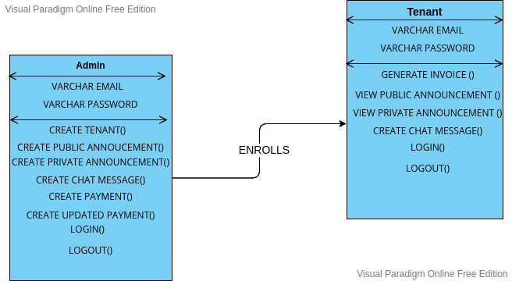

## Database tables

Using the MYSQL language a relational database was developed with each table containing different elements that communicate with one another**.**

# CHAPTER SIX

## SYSTEM IMPLEMENTATION

**After development of the database for the system, the implmentation stage commenced and in at this jancture a number of activities were carried out and a set of techniques was implemented to build the system. Development began with designing of the website structure with the help of HTML, and an incorporation of styling was done using CSS. Contents of the database were managed using PHP language.**

In this chapter other two critical phases were conducted, testing and evaluation stages. In the testing stage, analyses of the system’s functionality was conducted and the evaluation stage was done on the tenant’s page and the Admin page.

## Changes that were proposed

### Parallel running

In this technique, both the manual system that was being implemented should not stop and at the same time the new computerized system will become used. This is effective in determining how effective one system compared to another. If the new system got approved then the old system would become obsolete.

### Phased implementation

In this technique a portion of the management activities to carried out using the new system while another part remains to become executed using the old system. It allows for the gradual change in the work environment and also mitigates negative effects that could become brought about by using the new computerized system.

### Direct changeover

In this method a day is allocated where all functions would seize to use books and files to record financial records and implementation of the new financial management system is implemented. The method is more easier and cheap in implementing.

# CHAPTER SEVEN

## LIMITATIONS, CONCLUSIONS AND RECOMMENDATIONS

### Limitations

In implementation of the project, time was inadequate to incorporate additional functionalities.

## **Recommendations**

In the future additional features could become implemented:

The Admin dashboard to include total income of all tenants in real-time.

Payment automation in the system.

Tenants capability to change their username and password.

### Conclusion

Real estate can become defined as a combination of land and any permanent structures done on it towards its improve whether man-made or naturally situated. For example, minerals, residential rental property and trees. As population increases more rental properties will grow in demand and property managers and real estate agents will become tasked in managing their tenants while ensuring quality of service. Technological advancements in real estate will become the norm and will enhance quality of services provided by home owners.

References

Kariuki, J., 2017. [online] Available at: <https://www.businessdailyafrica.com/bd/corporate/technology/why-kenya-is-yet-to-fully-embrace-cloud-computing-2180528#:~:text=In%20Kenya%2035.6%20per%20cent,Bureau%20of%20Statistics%20(KNBS).> [Accessed 16 March 2022].

Odhiambo, O. *Curriculum Vitae* [Ebook]. Retrieved 21 April 2022, from <https://profiles.uonbi.ac.ke/files/177890_CVOpole.pdf>.

*Online room application for Academic Year 2021/2022 | University of Nairobi*. Uonbi.ac.ke. (2021). Retrieved 21 April 2022, from <https://uonbi.ac.ke/news/online-room-application-academic-year-20212022>.

*Financial Management | Oracle Kenya*. Oracle.com. Retrieved 21 April 2022, from <https://www.oracle.com/ke/erp/what-is-financial-management-system/>.

*Most preferred student accommodation in Nairobi - Qwetu.co.ke*. Qwetu.co.ke. Retrieved 22 April 2022, from https://qwetu.co.ke/.